**Prerequisite To run RPA BOT**

* **Install Sophos VPN**
  + Request access for Sophos VPN. Point of Contact - [kodanda.p.chinnabba@accenture.com](mailto:kodanda.p.chinnabba@accenture.com)
  + For the Sophos installation follow the attached document and connect to the vpn



* **Install Sap GUI 7.50**
  + Follow the attached document for how to download, install the SAP GUI 7.50 and how to connect to E4L form Sap GUI 7.50



* + Request account creation for E4L System. Point of Contact - [kodanda.p.chinnabba@accenture.com](mailto:kodanda.p.chinnabba@accenture.com)
* **Install Desktop Agent**
  + Download the Desktop Agent from the below link: <https://ts.accenture.com/sites/ASBSG_2/ASBSG%20Main/31%20Studio/10%20Apps/60%20Digital%20PM%20Calibration/Deliverables/INT_RPA_AGENT00P_1-80004525.MSI>
  + Run the exe file and install the desktop Agent.
  + Once desktop Agent is installed create one folder with the name Tenants in the path “**C:\ProgramData\SAP\Intelligent RPA”** and copy and paste the attached **master.json** file in the Tenants folder.

 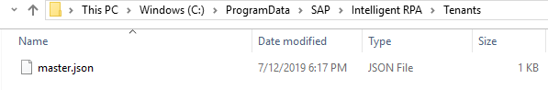

* + Now go to start of your desktop and search for the Desktop Agent and click on the agent. Enter the S User credential in the login screen. You will be able to login successfully if you have followed all the steps properly.
* **Register the user system in Cloud Factory**
  + Get the system name from This PC -> Properties -> Computer Name

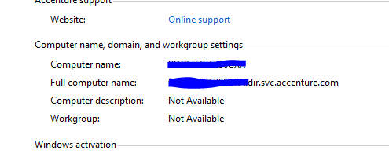

* Register the system name to cloud factory. Contact Person - [kodanda.p.chinnabba@accenture.com](mailto:kodanda.p.chinnabba@accenture.com)
* **Download GaugeReader**
  + Download the GaugeReader from the following location and extract it: <https://ts.accenture.com/sites/ASBSG_2/ASBSG%20Main/31%20Studio/10%20Apps/60%20Digital%20PM%20Calibration/Deliverables/GaugeReader.zip>
* **Install and Run GaugeReader**
  + To install the GaugeReader follow the steps mentioned in the below document.



* **RUN RPA BOT** 
  + To run the RPA bot, click on the Desktop Agent icon under hidden icons.
  + In the pop-up select the bot that you want to run. In this case Digital PM Calibration as shown below.

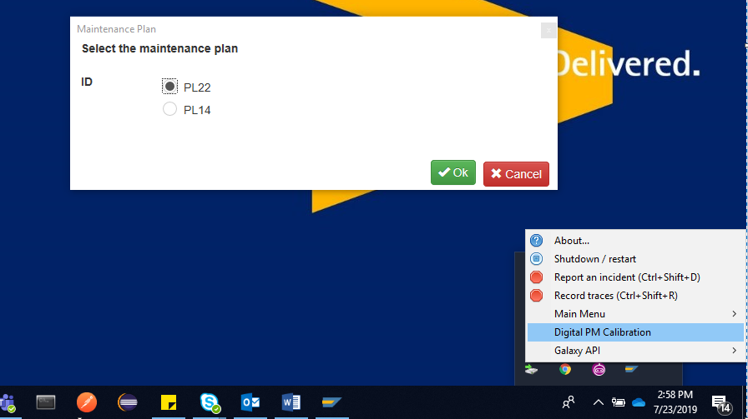

* Another pop-up will open asking you to select the maintenance plan. Select the plan as required and click on OK button.
* Now the bot will start and perform actions on its own.
* At one point the bot throw a pop as shown below

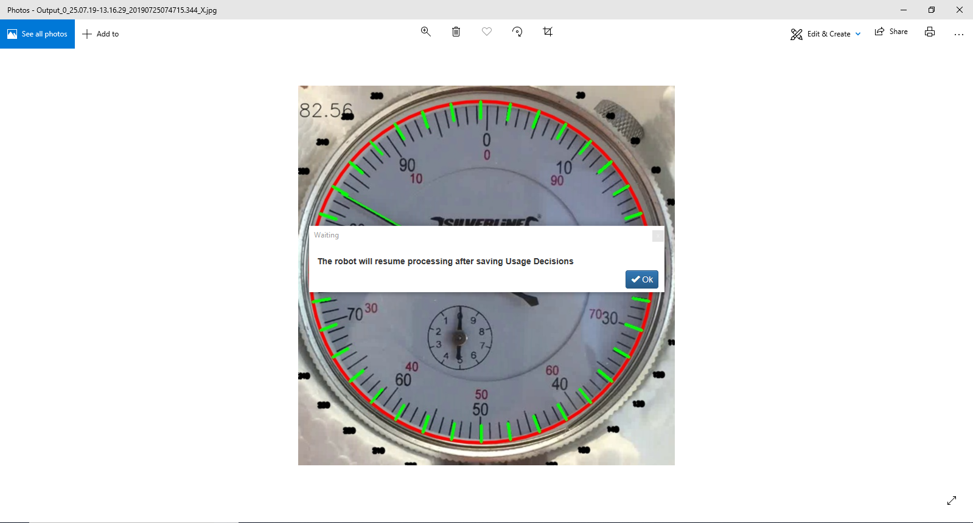

* Click OK button.
* After this set the UD code to A or A1.

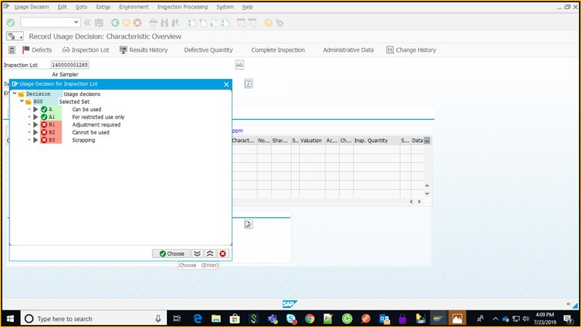

* Save the changes.

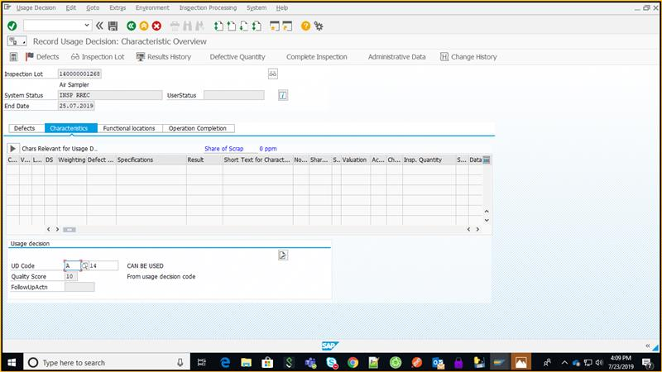

* Once saved, the bot will start once again, and download the certificate to your documents folder. At this point the RPA process is over.
* To print the certificate manually do the following: Navigate to SP01 -> Execute -> Click on the Type Icon.